Student Name:Yunus Emre TORUN

Student ID:21428451

Dates:17.08.2018-12.10.2108

Year:3

Company Name:SDT

Company Division:Radar-EW signal processing, image processing/pattern recognition,

embedded software/systems, satellite technologies and simulation & training systems

Department:Electronic Warfare and Communication

Supervisor:Ediz Çelik,Türker Dolapcı



Table of Contents

1.INTRODUCTION 2

2.DESCRIPTION OF THE COMPANY 3

2.1 COMPANY NAME 3

2.2 COMPANY LOCATİON 3

2.3 GENERAL INFORMATION ABOUT THE COMPANY 3

2.4 VİSİON AND MİSSİON 4

2.4.1 Mission 4

2.4.2 Vision 4

3. FIRST WEEK AND SECOND WEEK 5

3.1 INTRODUCTION to ANTENNAS 5

3.1.1 FIELD REGION 6

3.1.2 RADIATION PATTERN 7

3.1.3 DIRECTIVITY 8

3.1.4 GAIN 8

3.1.5 BANDWIDTH 9

3.1.6 VOLTAGE STANDING WAVE RATIO 9

3.1.7 S PARAMETERS 10

3.1.8 THE FRISS EQUATION 10

4.THIRD WEEEK 11

4.FOURTH WEEK 13

5.FİFTH WEEK 16

6.SIXTH WEEK 19

# 1.INTRODUCTION

I have completed my internship in STD(SPACE & DEFENCE TECHNOLOGIES), which is the important part of defense industry of Turkey. SDT possesses special expertise in Radar-EW signal processing, image processing/pattern recognition, embedded software/systems, satellite technologies and simulation & training systems. SDT is very well recognized by SSM (Undersecretariat For the Turkish Defense Industries) and is also a full member of SASAD (the Defense Industry Manufacturers Association of Turkey).

My intership has started 17.08.108 and finished 12.10.2018. Actually due date was 05.10.2018 I didnt go for a week so I protract due date because of makeup exams.Then when the first day I explored and visited company to see how organisation is and met engineers and supervisior who working there.Feast of the sacrifice holiday was beginnig so second day was almost 9 days later started.

My department was Electronic Warfare and Communication and my helper engineer be interested antenna and microwave departments who is Türker Dolapcı.So I was informed of anttennas,Link budget calculatino ,laboratory devices,signal processing and programming language(matlab).

This reports contains what I have done and observed with a detailed description in the internship.I combined Theorical and practical knowledge in laboratory and computer skills.

# 2.DESCRIPTION OF THE COMPANY

## 2.1 COMPANY NAME

SDT(SPACE & DEFENCE TECHNOLOGIES)

## 2.2 COMPANY LOCATİON

SATGEB-2 Titanyum C Blok Üniversiteler Mah. İhsan Doğramacı Bulvarı Bina No: df 37 No: 1, -1/1 ODTÜ Teknokent Çankaya Ankara / Türkiye

## 2.3 GENERAL INFORMATION ABOUT THE COMPANY

SDT Space & Defence Technologies Inc. (SDT) is a privately owned Turkish company which has been developing indigenous software, hardware and integrated solutions for Defence, Space and Aviation areas since February 2005. SDT’s facilities are located at METU Technopolis Area.SDT possesses special expertise in Radar-EW signal processing, image processing/pattern recognition, embedded software/systems, satellite technologies and simulation & training systems. SDT is very well recognized by SSM (Undersecretariat For the Turkish Defense Industries) and is also a full member of SASAD (the Defense Industry Manufacturers Association of Turkey).SDT’s Quality System is established per ISO 9001:2008 and it is certified per ISO 9001:2008. SDT’s operations and products meet internationally accepted engineering, quality management, configuration management and program management standards, among them, there are ISO 9001:2008, IEEE 12207, IEEE 1220, MIL-STD-498 and MIL-ST-973 and PMI/PMPHandbook. Currently, SDT is fulfilling several direct development contracts with SSM as well as development and production contracts with main system integrators.

## 2.4 VİSİON AND MİSSİON

### 2.4.1 Mission

Provide sustainable, competitive and reliable Turkish products and engineering solutions both in national and international markets by respecting all stakeholders’ interests.

### 2.4.2 Vision

Being;

a preferred company both in national and international markets due to its designed & manufactured products

an efficient and effective company that grows both in domestic and international markets via its cooperation & teaming approach and

a company that improves the satisfaction of its employees, shareholders, customers, suppliers and the whole society.

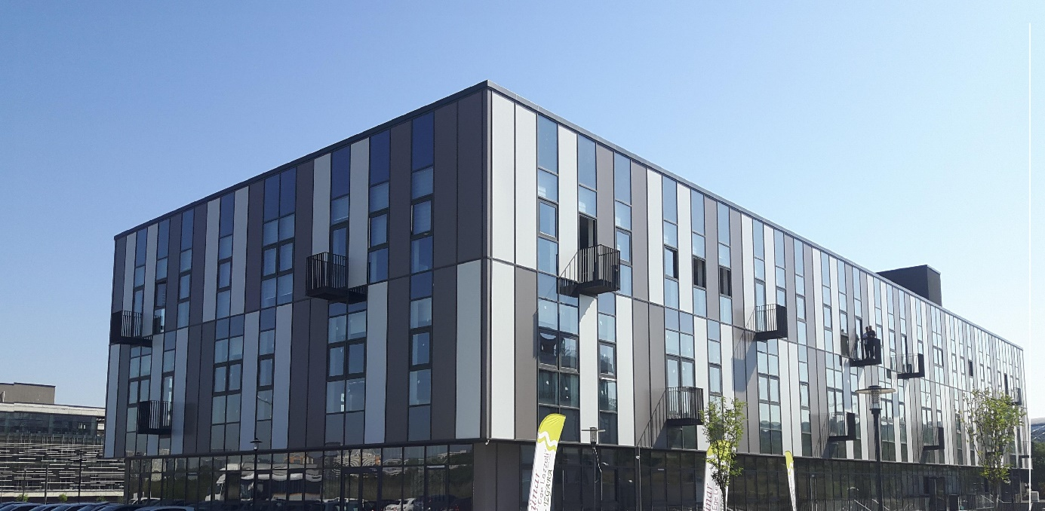

# 3. FIRST WEEK AND SECOND WEEK

During the first and second week I learned some information antennas these are how it is work,why we are using,where we are using ect.And I decide to experiment with receiver and trasmitter antennas in laboratory.Firts of all I investigate data sheets of antennas.That is the most important information of experiment as when I will execute the experiment it could be became un-solicited status.During experiment I prepared a power point presentation about antennas.

I asked to enginner about topics of antennas theory I didnt understand when I prepared the presentation.Sometimes he explained and suggested textbook.

Here is a presentation of antennas-theory what I prepared it

## 3.1 INTRODUCTION to ANTENNAS

In the 1890s, there were only a few antennas in the world. These rudimentary devices were primarly a part of experiments that demonstrated the transmission of electromagnetic waves. By World War II, antennas had become so ubiquitous that their use had transformed the lives of the average person via radio and television reception. The number of antennas in the United States was on the order of one per household, representing growth rivaling the auto industry during the same period.

3.1.1 FIELD REGION

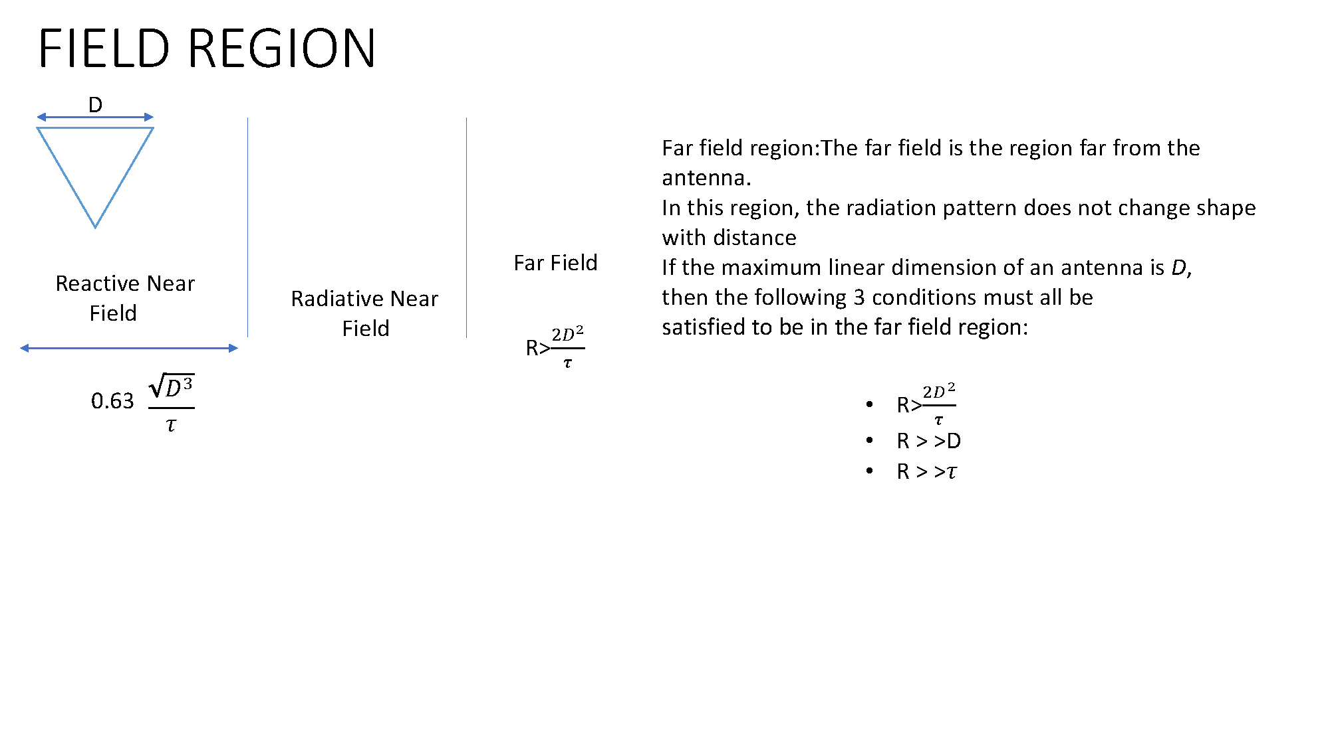

### 3.1.2 RADIATION PATTERN

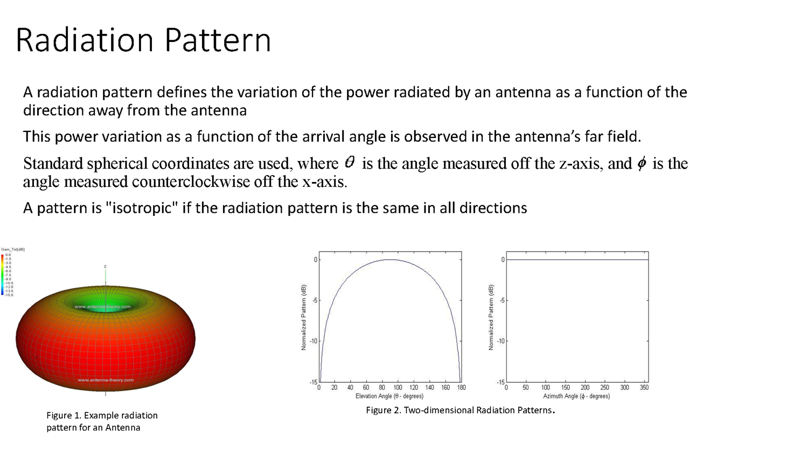

3.1.3 DIRECTIVITY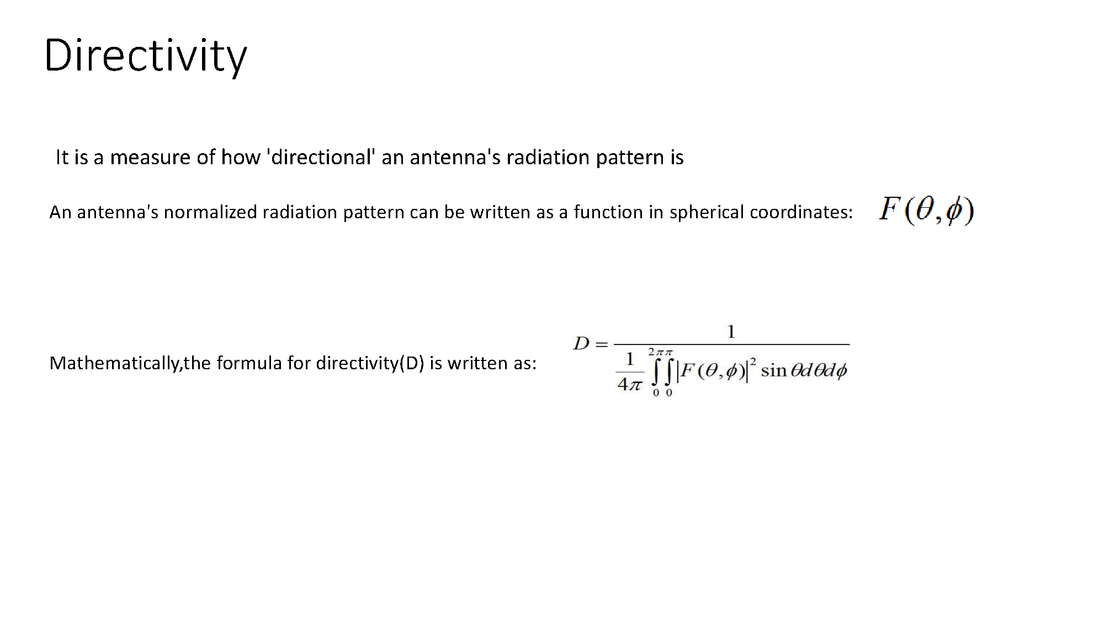

### 3.1.4 GAIN

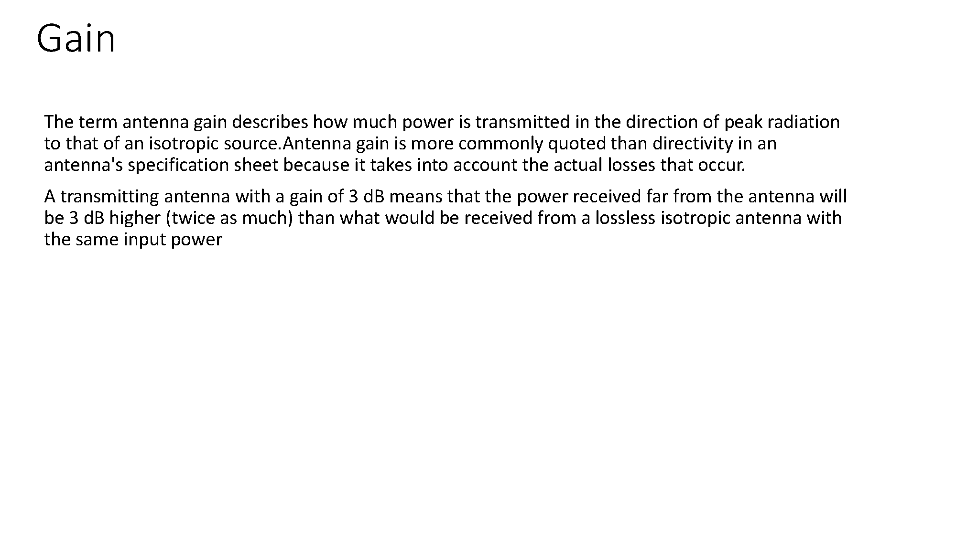

3.1.5 BANDWIDTH 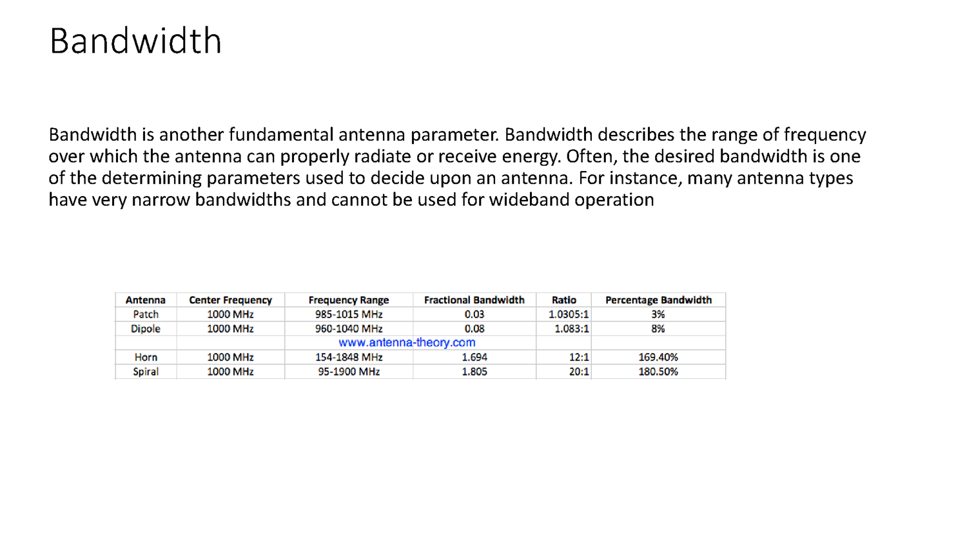

3.1.6 VOLTAGE STANDING WAVE RATIO 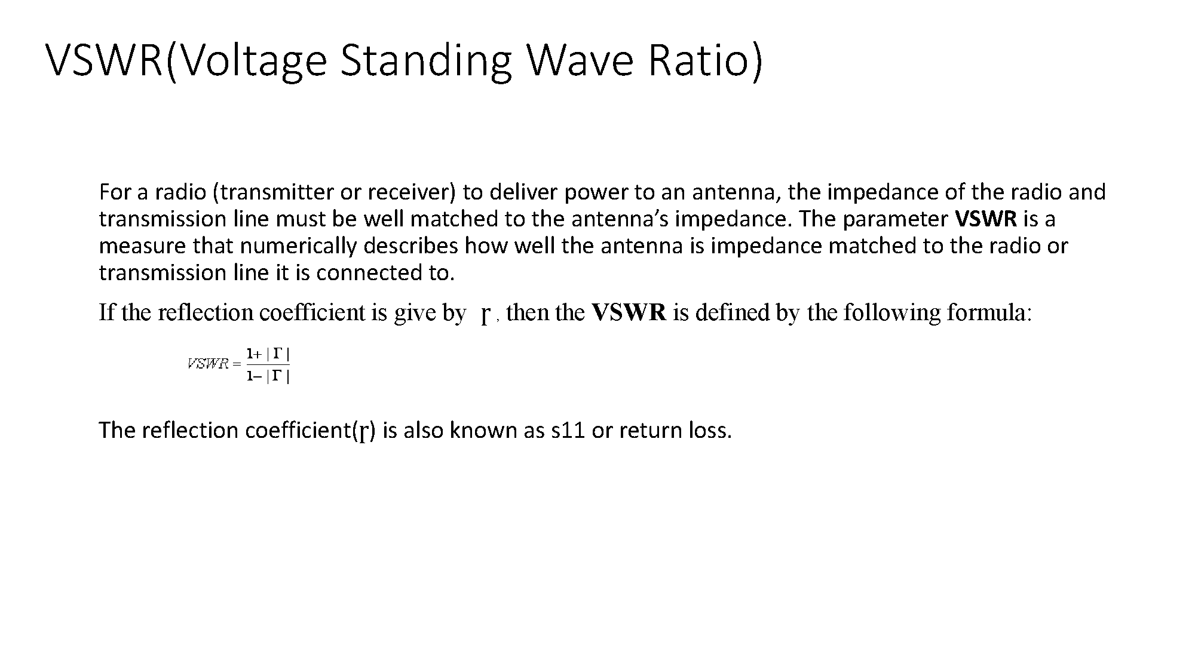

3.1.7 S PARAMETERS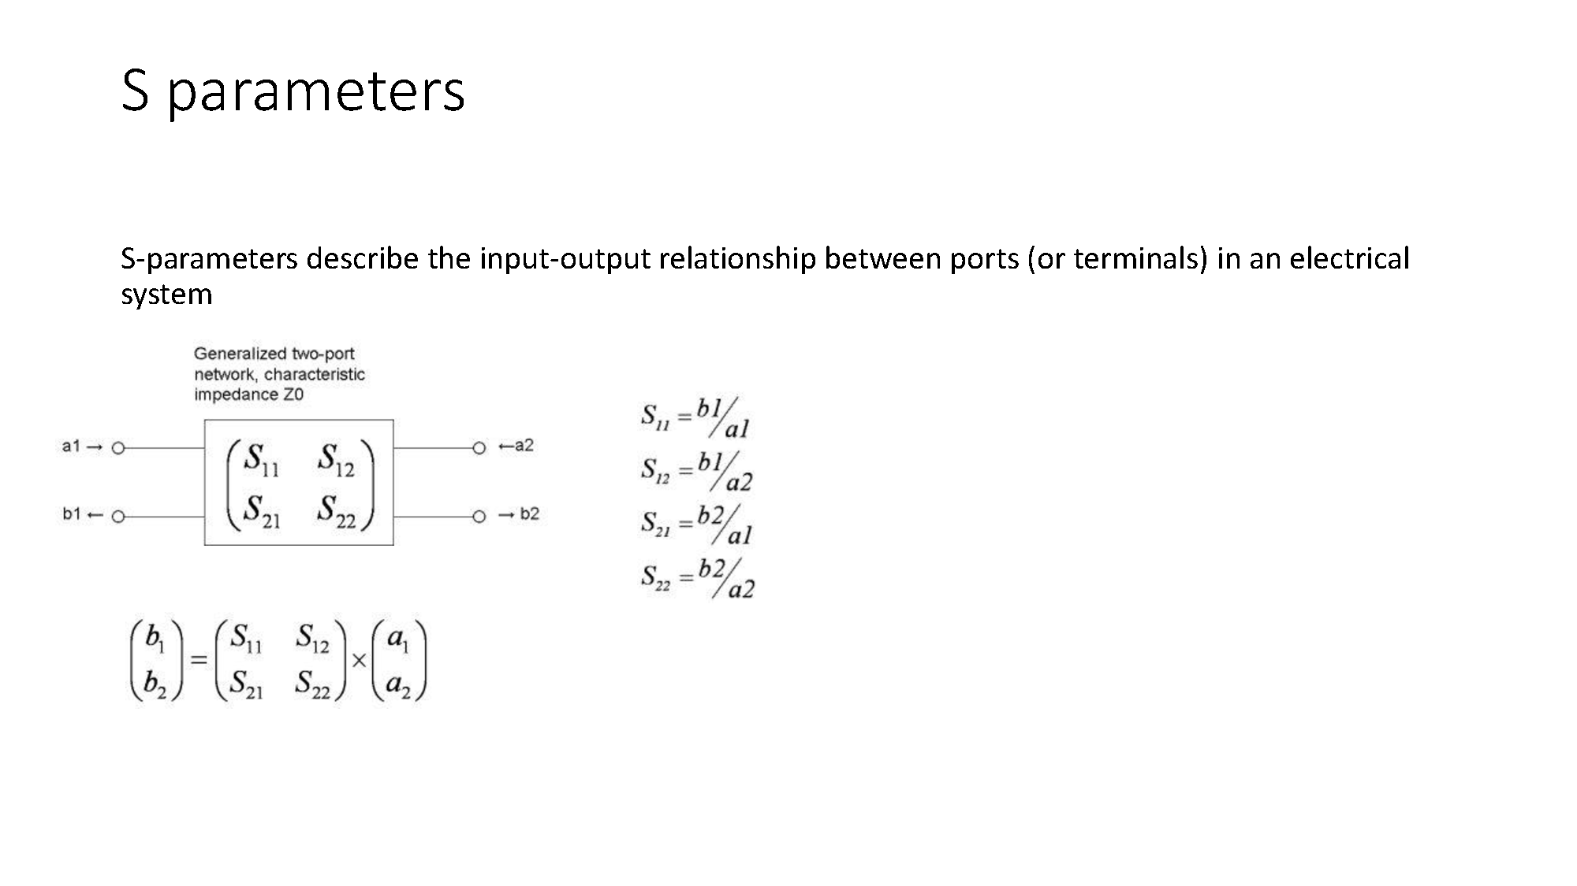

### 3.1.8 THE FRISS EQUATION

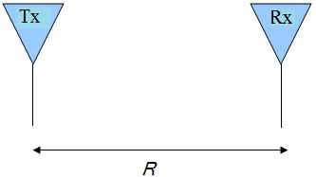

* Assume that friis transmission formula Watts of total power are delivered to the transmit antenna
* If the transmit antenna has an antenna gain in the direction of the receive antenna given by http://www.antenna-theory.com/basics/power3.bmp
* The gain term factors in the directionality and losses of a real antenna. Assume now that the receive antenna has an effective aperture given byantenna theory. Then the power received by this antenna (antenna tutorial) is given by:

Friis

* Since the effective aperture for any antenna can also be expressed as:

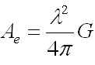

# 4.THIRD WEEEK

During third week I started experiment.First of all I thouhgt which antennas could be used and how could be positioned.First purpose of mine was wanted to not burn the recevier.Then I designed the distance between antennas

Here ı used antennas;

Receiver Antenna(Spiral,QMS-00767)

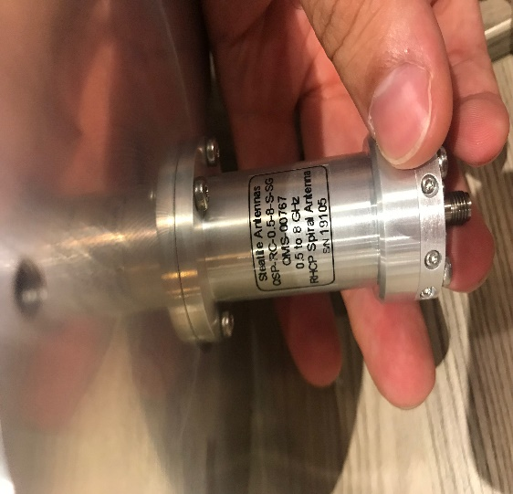 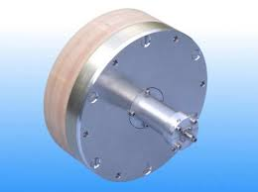

Trasmitter Antenna(Horn,WBH2-18N)

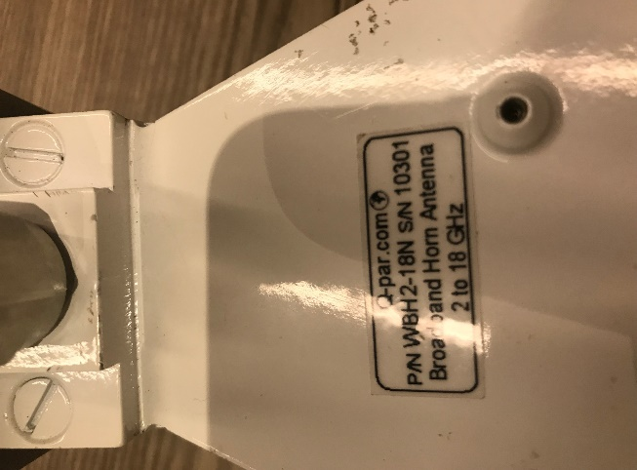 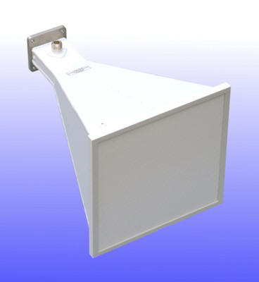

Purpose of Experiment: I placed the antennas at a certain distance then I sent a radiating beam by horn antenna and transmitter antenna got that beam finally I checked it by signal analyzer

And I used RF cable of this experiment.Cables are expensive but

minumum loss

RF cable and signal analyzer

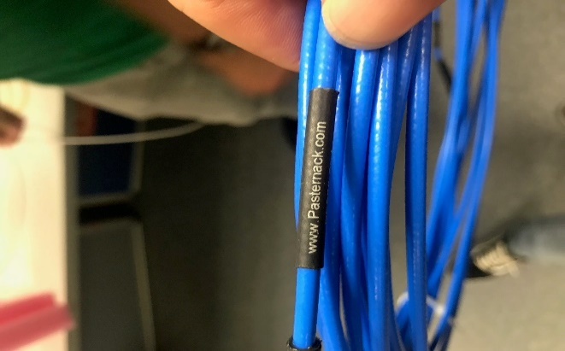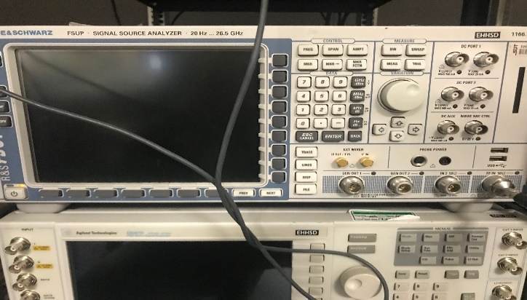

Schema of experiment ; 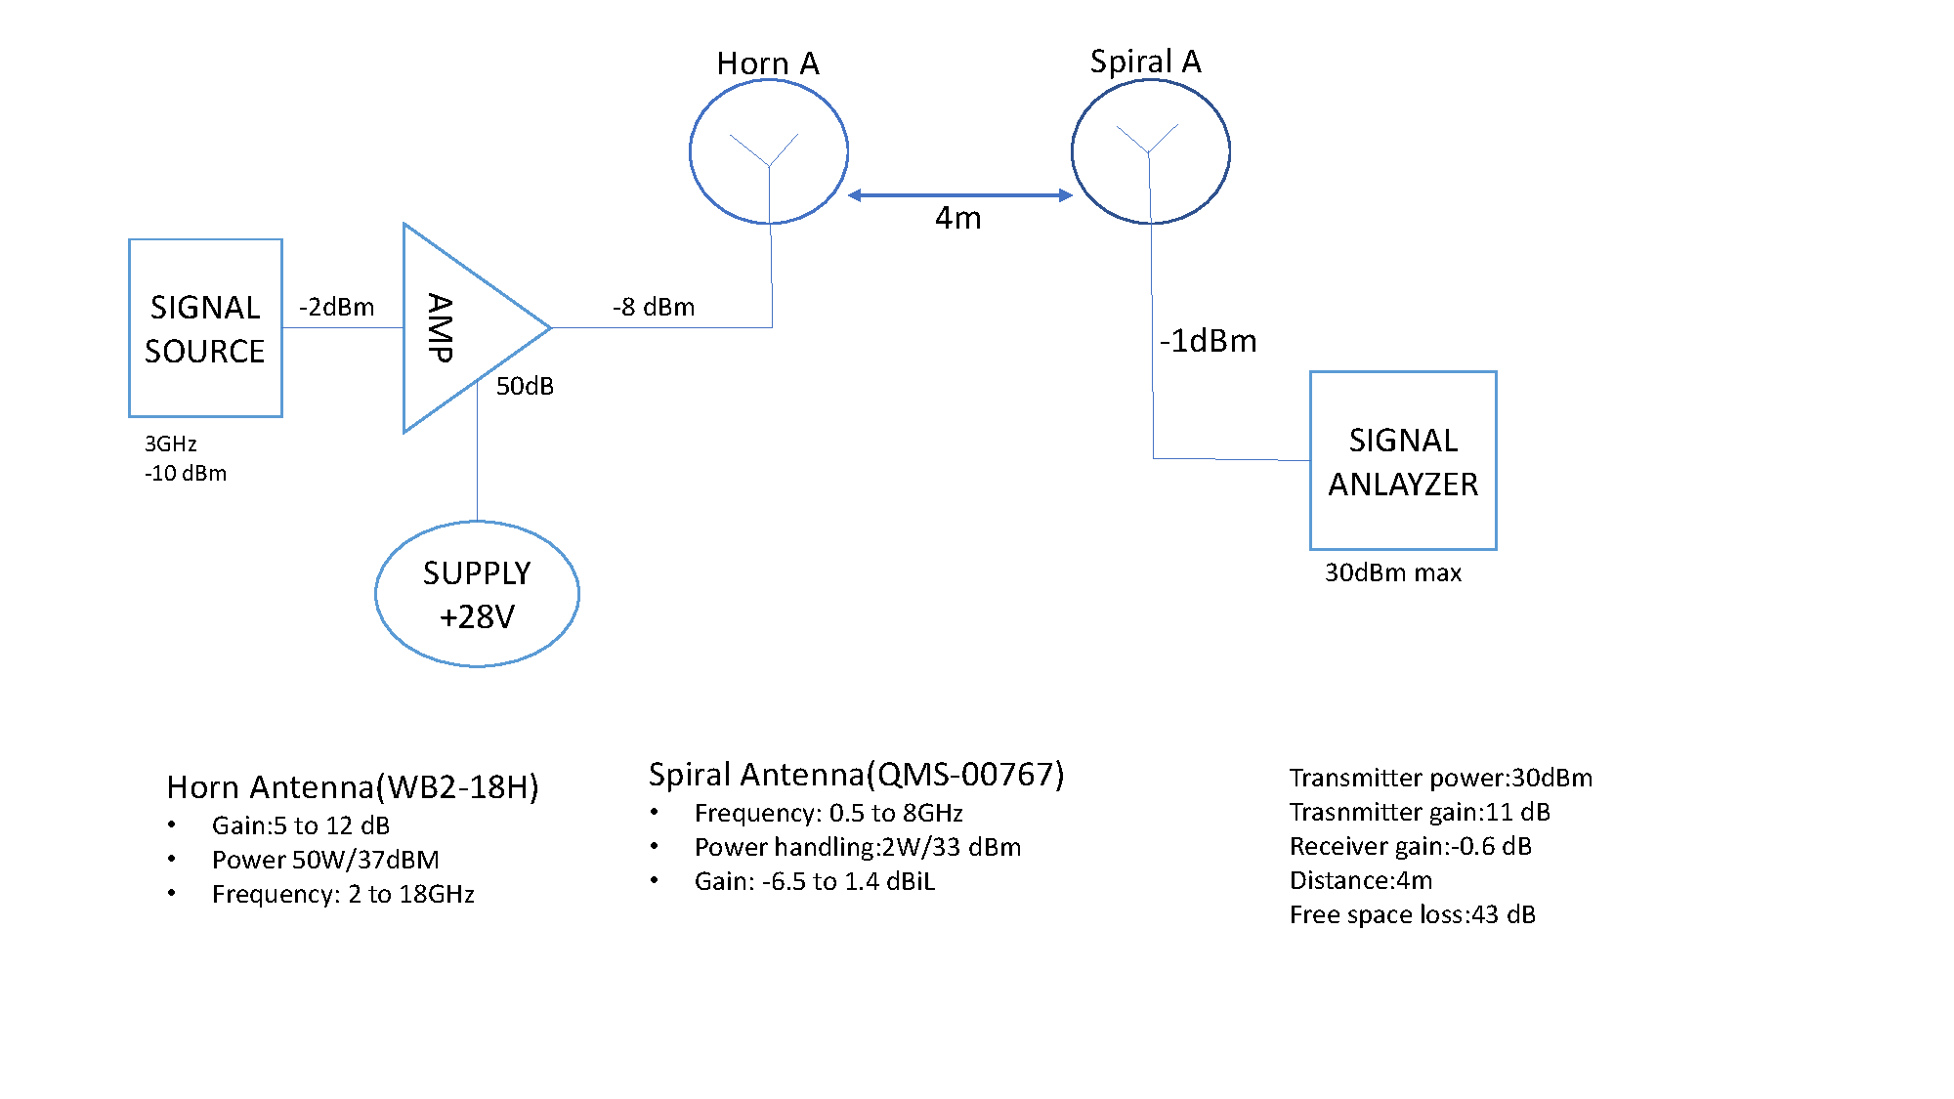

# 4.FOURTH WEEK

When I finished the experiment then I proposed to him to learn Matlab with him help so I started some basic Matlab rules by using website of Matlab.My purpose of using Matlab was essentially signal processing and draw a graph.

Codes of during first week of coding;

First code

clear all;

close all;

clc;

fDev=50; %deviation

g=5;

f1=100000; % center frequency

fs=220000; % sample frequency

T=1/fs; % periot

t=0:T:0.2;

x=(g/10)^10*sin(2*pi*f1*t)+316*randn(size(t)); % signal with noise

y=fmmod(x,f1,fs,fDev); % fm signal

yfft=fft(y); % spectrum of fm

f=linspace(-fs/2,fs/2,length(x));

plot(f,abs(yfft));

Second code

clc

close all

clear all

kf=0.5

fm=100;

fs=3*fm;

t=0:1/fs:1;

x=pi

m=sin(2*x*fm*t);

r=length(m)

y=abs(fftshift(fft(m,r))/r);

f=linspace(-fs/2,fs/2,r)

figure

plot(f,y)

fc=100000;

sig_carr=sin(2*x*fc*t)

z=cos(2*pi*fc*t+kf*cos(y));

figure

plot(f,z);

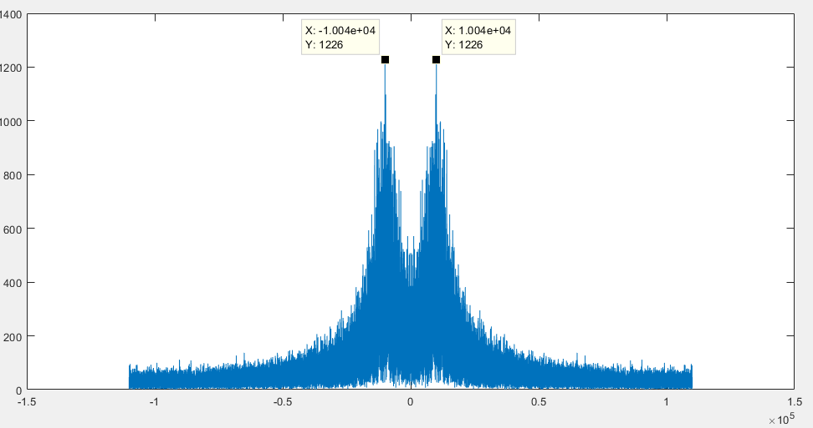

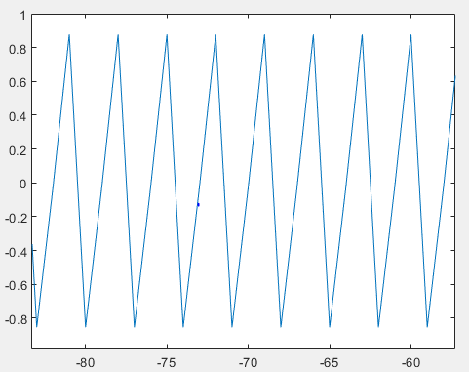 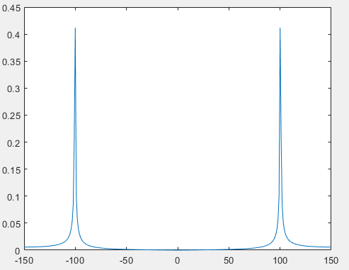

# 5.FİFTH WEEK

In the fifth week I started to code transmitter and receiver systems that was my experiment in the beginning of internship.Fifth and sixth weeks I finished the coding

First of all I processed sinsusoidal signal to transmitted to receiver like radio communication than I processed sound later I listened it. I regarded noise,link budget and frequencies to processed it.

clear all;

close all;

clc

fDev=1e3;

fDevJ = 20e3

fc=1000; % frequency of signal

%% audio

load handel.mat;

info=audioinfo('counting.wav');

[y,Fs]=audioread('counting.wav');

y=y(1:160000);

%% constants

k=1.380*(1e-23); % boltzman constant J.K^-1

T=290; % temperature ususally 290 K

B=10*1e3; % Bandwidth of effective noise

R=50 ; % impedance of transmitter

d=1000; % distance between antennas

c=3*1e8;

lambda=c/fc;

%% Noise %%%%%%%

Vn=sqrt(k*T*B*8*R); % peak voltage of noise https://www.radio-electronics.com/info/rf-technology-design/noise/thermal-calculations.php

Vn_db=20*log10(Vn);

n=Vn*(-1+2*rand(size(y))); % noise signal

%% Antennas Gain %%%%%%%

rg_db=5; % receiver db gain

tg_db=1; % transmitter db gain

rg_ant=10^(rg_db/20); % voltage magnitude gain

tg_ant=10^(tg_db/20); % voltage magnitude gain

%% Main Signal %%%%%%%

tx_watt=5;

Amp_sig=sqrt(tx_watt*R*2);

sig=Amp_sig*y;

%% Carrier and Fm Signal %%%%%%%

fcarr=500e3; % frequency of modulated signal

fs2=4*fcarr; % sample

fm_sig=fmmod(sig,fcarr,fs2,fDev); % fm signal

fftlen=length(fm_sig);

f=linspace(-fs2/2,fs2/2,fftlen);

X=abs(fftshift(fft(fm_sig,fftlen))/fftlen);

figure

plot(f,X);

%%%%%%% Input Output Power %%%%%%%

tx_output=sqrt(2*R*tx_watt); %voltage magnitude

tx_output_db=10*log10(1000*tx_watt);

fspl_db=20*log10(d)+20*log(fcarr)-147.55;

fspl= 4*pi*d/lambda; % free space path loss

fspl_2=20*log10(fspl);

rx_input=(tx_output*rg_ant*tg_ant/fspl)*fm_sig;

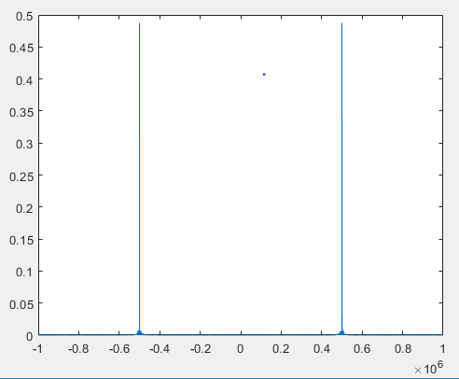

# 6.SIXTH WEEK

In this week I added jamming signal to kill the sound.All of this base of electronic warfare so I tried and saw it coding was working.Sound was coming out of microphone with distortion

And I plotted antenna figure of transmitter and receiver

clear all;

close all;

clc

fDev=1e3;

fDevJ = 20e3

fc=1000; % frequency of signal

%% audio

load handel.mat;

info=audioinfo('counting.wav');

[y,Fs]=audioread('counting.wav');

y=y(1:160000);

%% constants

k=1.380*(1e-23); % boltzman constant J.K^-1

T=290; % temperature ususally 290 K

B=10*1e3; % Bandwidth of effective noise

R=50 ; % impedance of transmitter

d=1000; % distance between antennas

c=3*1e8;

lambda=c/fc;

%% Noise %%%%%%%

Vn=sqrt(k*T*B*8*R); % peak voltage of noise https://www.radio-electronics.com/info/rf-technology-design/noise/thermal-calculations.php

Vn_db=20*log10(Vn);

n=Vn*(-1+2*rand(size(y))); % noise signal

%% Antennas Gain %%%%%%%

rg_db=5; % receiver db gain

tg_db=1; % transmitter db gain

rg_ant=10^(rg_db/20); % voltage magnitude gain

tg_ant=10^(tg_db/20); % voltage magnitude gain

%% Main Signal %%%%%%%

tx_watt=5;

Amp_sig=sqrt(tx_watt*R*2);

sig=Amp_sig*y;

%% Carrier and Fm Signal %%%%%%%

fcarr=500e3; % frequency of modulated signal

fs2=4*fcarr; % sample

fm_sig=fmmod(sig,fcarr,fs2,fDev); % fm signal

fftlen=length(fm_sig);

f=linspace(-fs2/2,fs2/2,fftlen);

X=abs(fftshift(fft(fm_sig,fftlen))/fftlen);

figure

plot(f,X);

%%%%%%% Input Output Power %%%%%%%

tx_output=sqrt(2*R*tx_watt); %voltage magnitude

tx_output_db=10*log10(1000*tx_watt);

fspl_db=20*log10(d)+20*log(fcarr)-147.55;

fspl= 4*pi*d/lambda; % free space path loss

fspl_2=20*log10(fspl);

rx_input=(tx_output*rg_ant*tg_ant/fspl)*fm_sig;

%% Receiver System %%%%%%%

SNRi_db=(tx_output_db+tg_db-fspl_db)/Vn_db ;

SNRi_lin=tx_output*tg_ant/(Vn*fspl);

SNRo_db=(tx_output_db+tg_ant-fspl_db)*rg_db/Vn_db;

SNRo_lin=(tx_output*tg_ant*rg_ant/(Vn*fspl));

noise_f2=(SNRi_lin/SNRo_lin);

n2_F=noise_f2*(-1+2*rand(size(y)));

n_tot=n2_F+n;

%fm_noise=fmmod(n_tot,fcarr,fs2,fDev);

%%

fc=10e3; % frequency of signal

SigDur=160000; % sample frequency

t=0:1/fs2:(1/fs2)*SigDur-1/fs2;

jam_pow=50;

amp_jam=sqrt(jam_pow*R*2);

jam_sig=amp_jam*sin(2*pi*fc*t);

fm_jam=fmmod(jam_sig,fcarr+5e3,fs2,fDevJ)

fm_jam = jam_sig;

figure(1);subplot(2,2,3);

plot(t,jam_sig)

%%

tot=jam_sig.'+rx_input+n_tot;

fm_demod=fmdemod(tot,fcarr,fs2,fDev);

subplot(2,2,1)

plot(fm_demod)

sound(fm_demod,Fs)

subplot(2,2,2)

plot(t,fm_jam)

%% Azimuth Antennas %%%%%%%

azi_angles=-180:180;

ant_gain=ones(1,length(azi_angles));

subplot(1,2,2)

polarplot(azi_angles/180*pi,20*log10(ant_gain)+2.15);

title('tx antenna');

rlim([-20,10]);

ant_gain2=(10.^(sinc(azi_angles/180)));

subplot(1,2,1)

polarplot(azi_angles/180*pi,20*log10(ant_gain2)-15);

title('rx antenna');

rlim([-15,5]);

SIGNAL OF SOUND

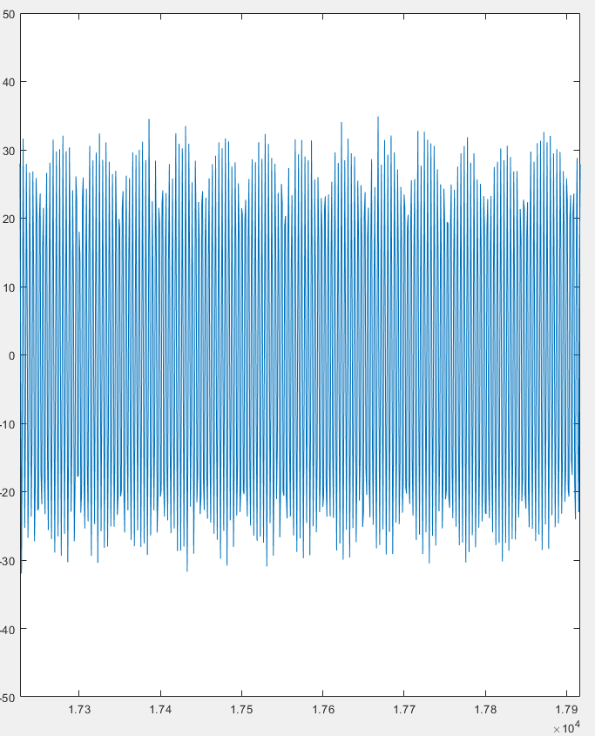

FIGURE FO ANTENNA

